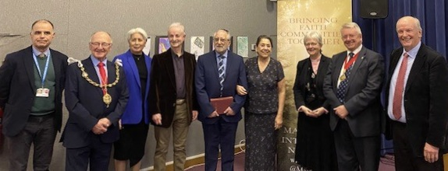
Members of the Maidstone Inter-Faith Network and honoured guests

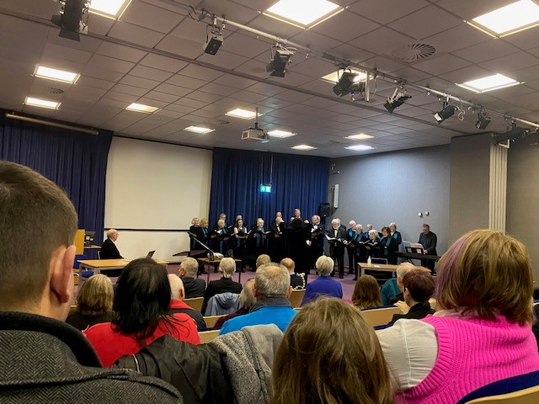
Maidstone Chorial Union
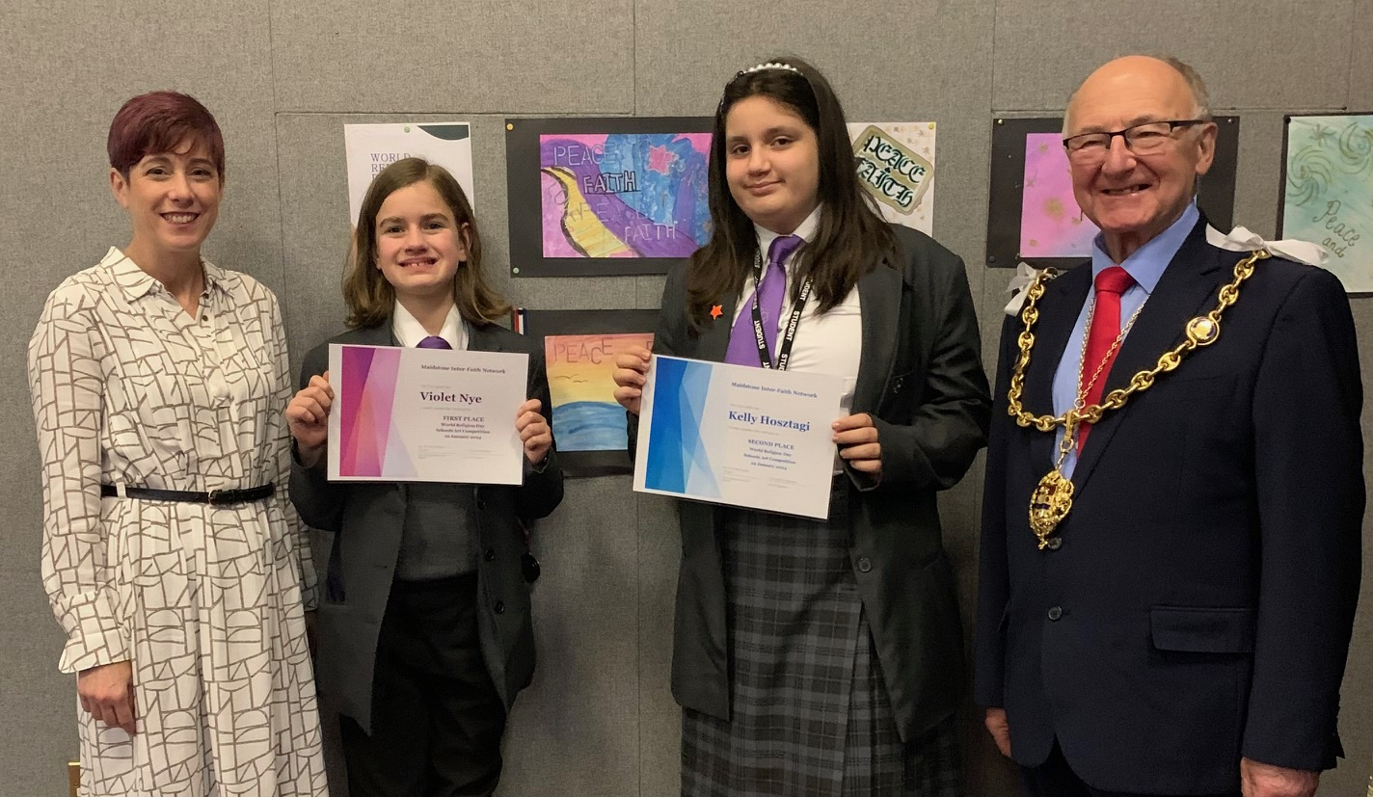
Art competition winners with the Mayor of Maidstone and Ms. Sarah Hayes from St Augustine Academy

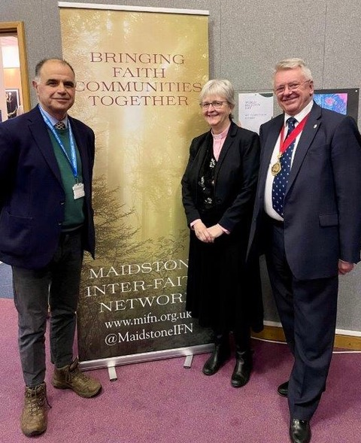
Maidstone Inter-Faith Network Chair Rev Dr Bonni-Belle Pickard with KCC Chairman Gary Cooke and KCC Cllr Chris Passmore

