SOME PHOTOS FROM THE ‘CREATION AND CREATIVITY’ EVENT HELD AT COUNTY HALL, MAIDSTONE ON 21 MARCH 2025

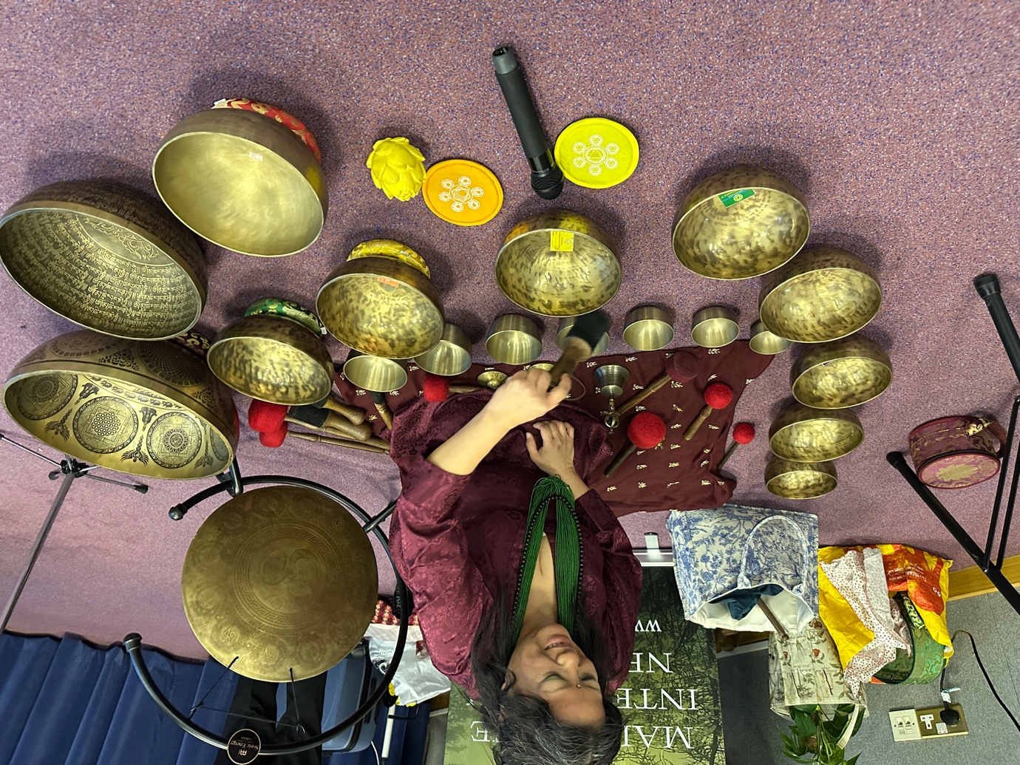
Before our event started the mood was set by the local Nepali Gurkha community who used meditation singing bowls to get us the right mood for the evening. They also played these after the event had finished and encouraged guests to try them – many did!
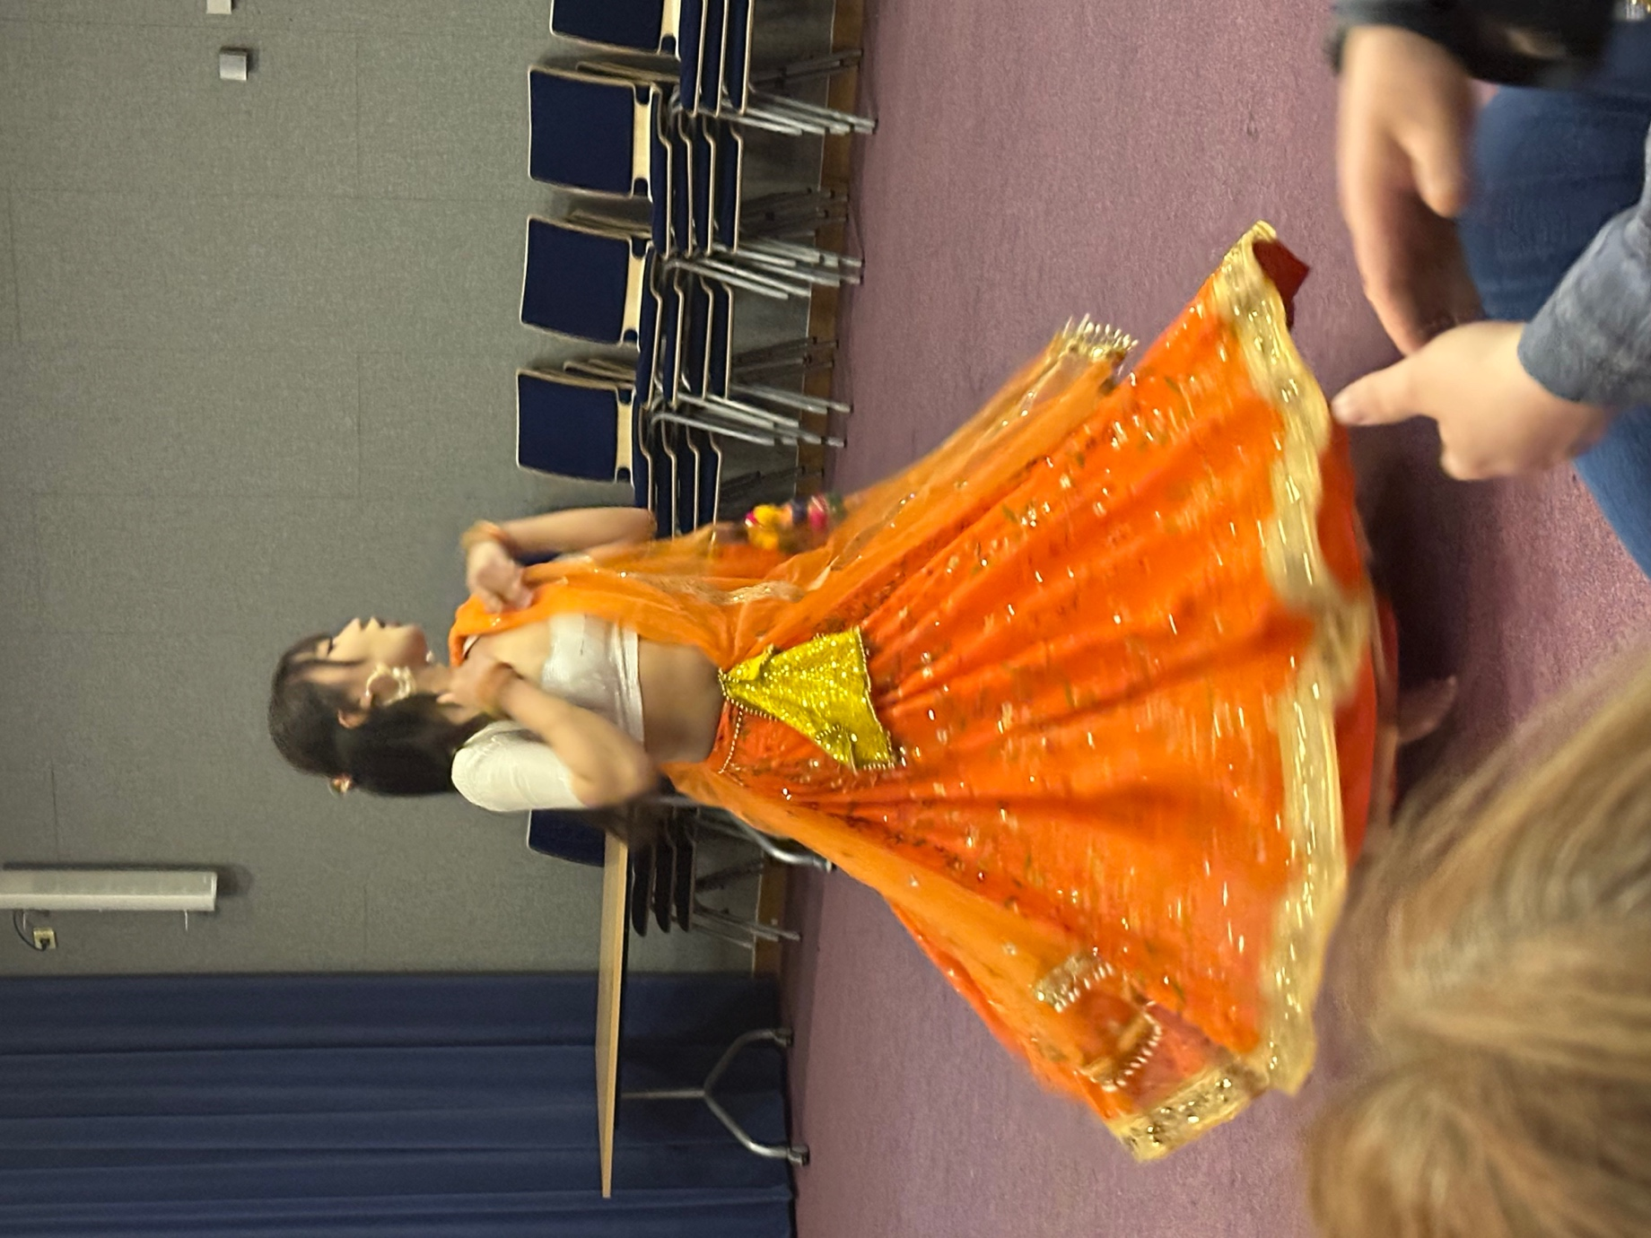
The Maidstone Nepali Gurkha community enchanted us with their wonderful dancing.
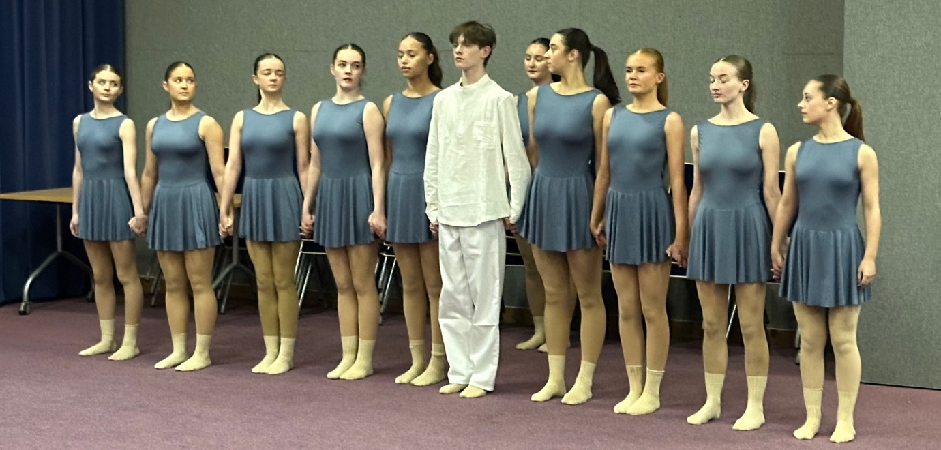

Maidstone-based Hilton Hall Dance Academy gave a moving performance.
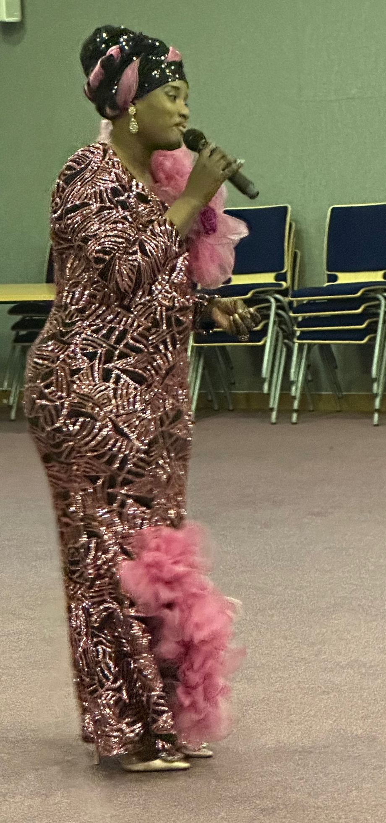
Gospel singer Mayowa Oyinloye got us on our feet with some rousing songs!
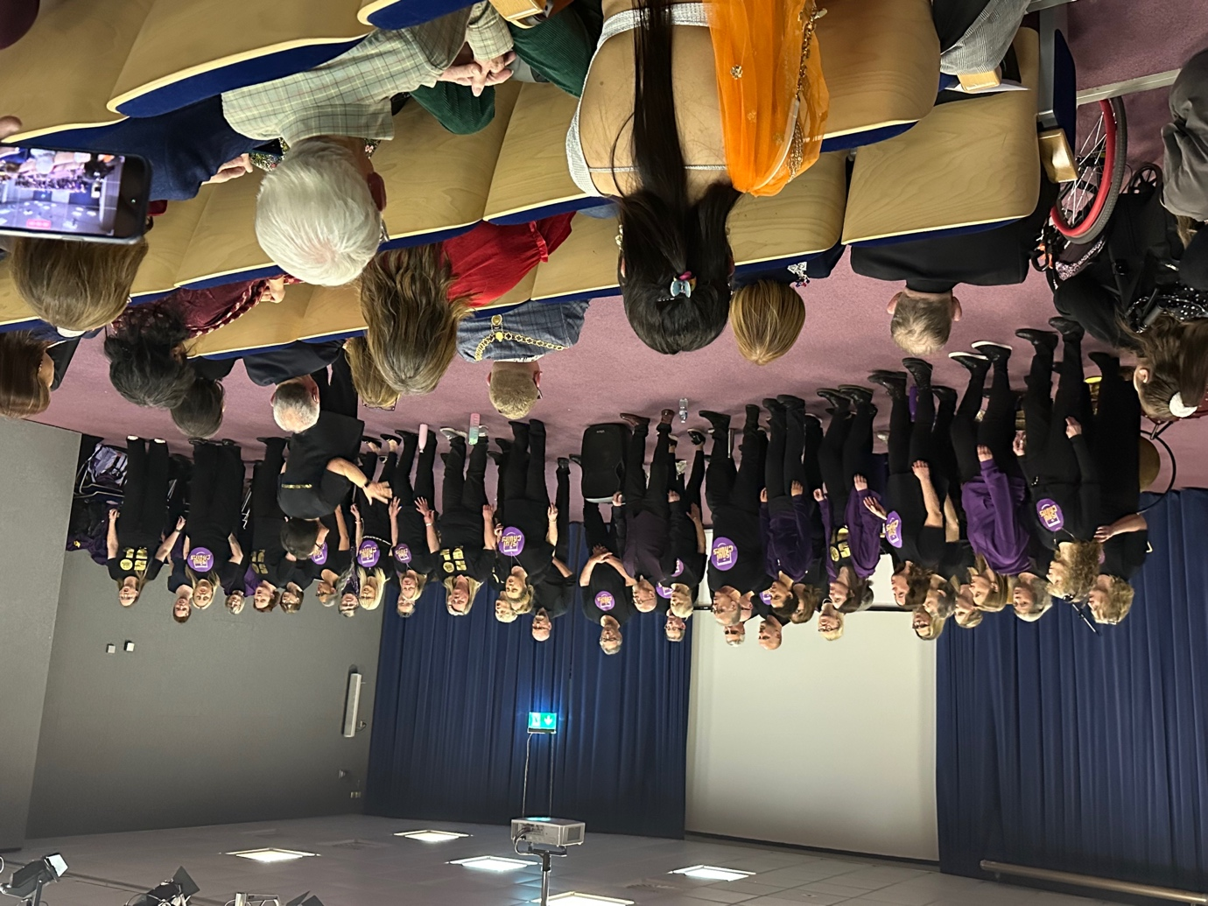
The Soul Choir finished the evening with some amazing songs. They are part of a larger network of choirs across Kent.

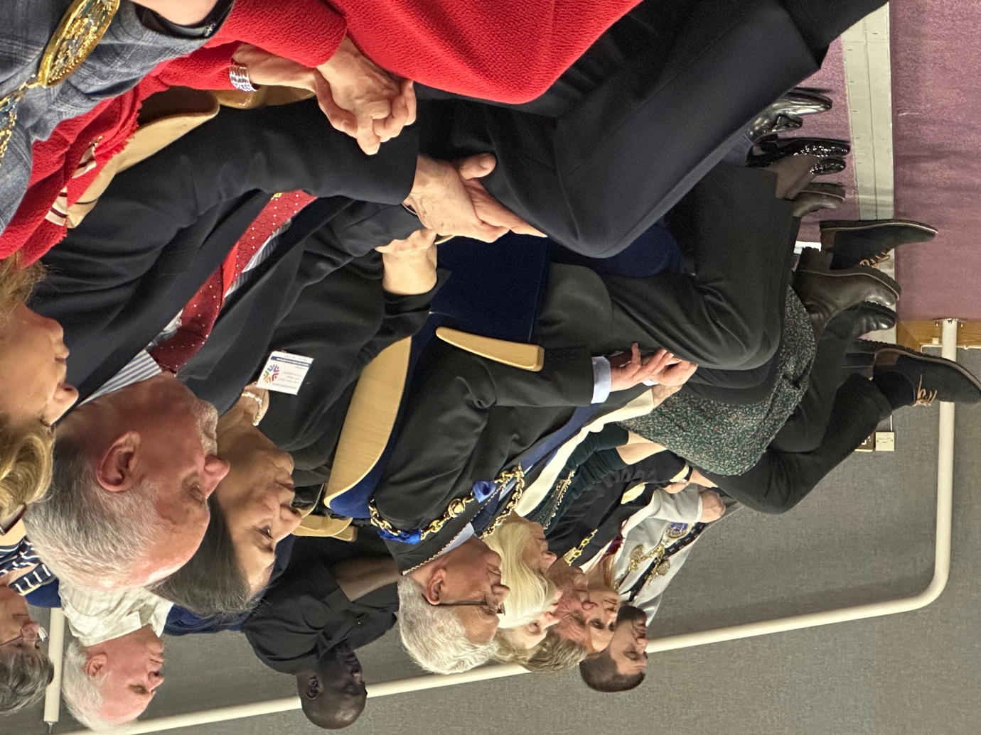
Some of the dignitaries who attended the event.
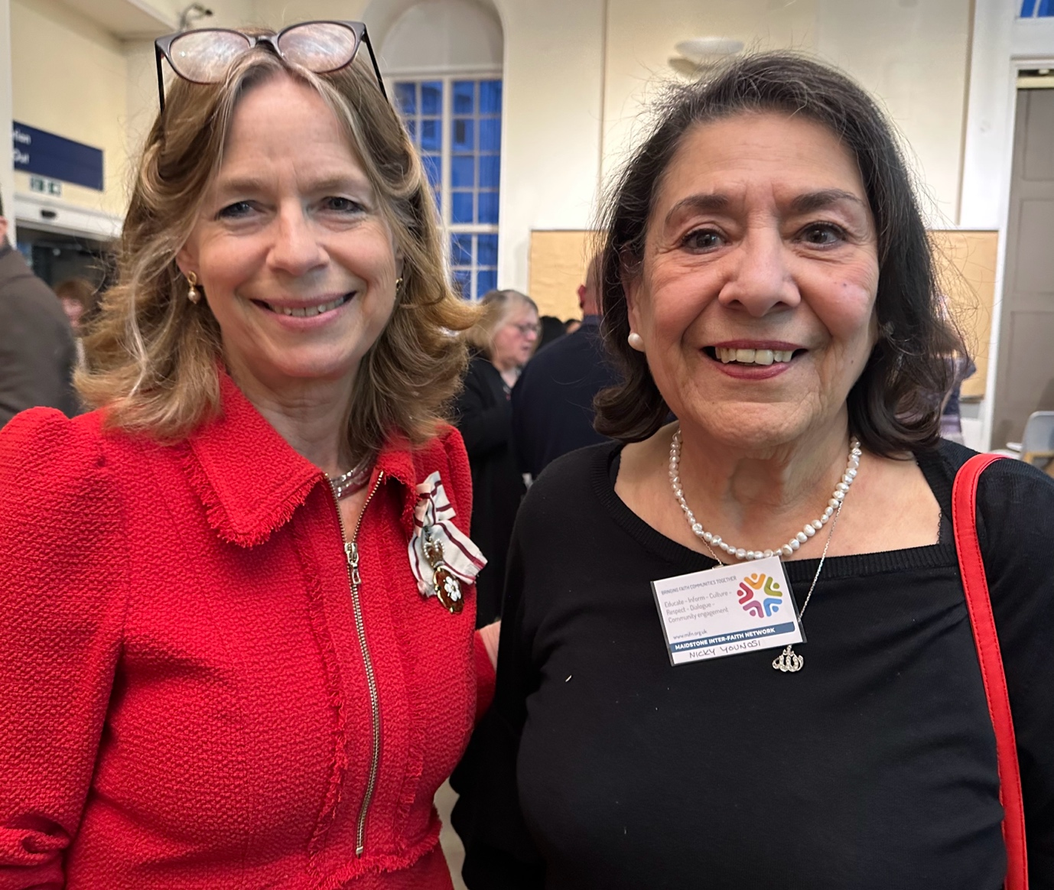
The Lady Colgrain (Lord Lieutenant of Kent), pictured with Maidstone Inter-Faith Network Vice Chair Nicky Younosi.
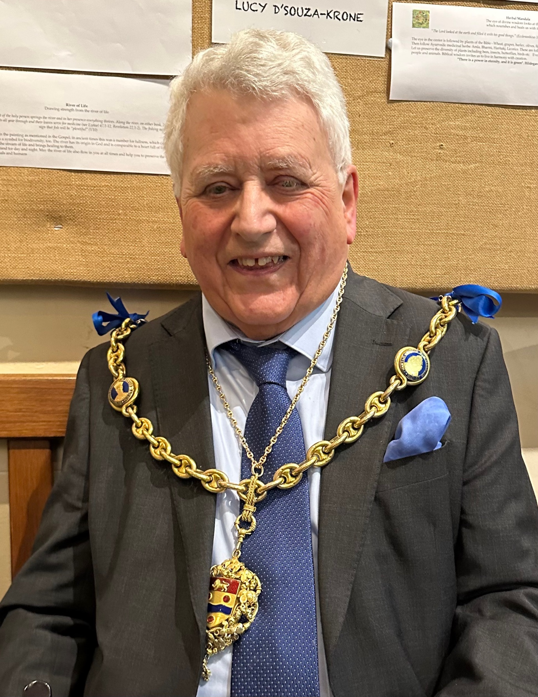
Our special guest Cllr. John Perry, Mayor of Maidstone.
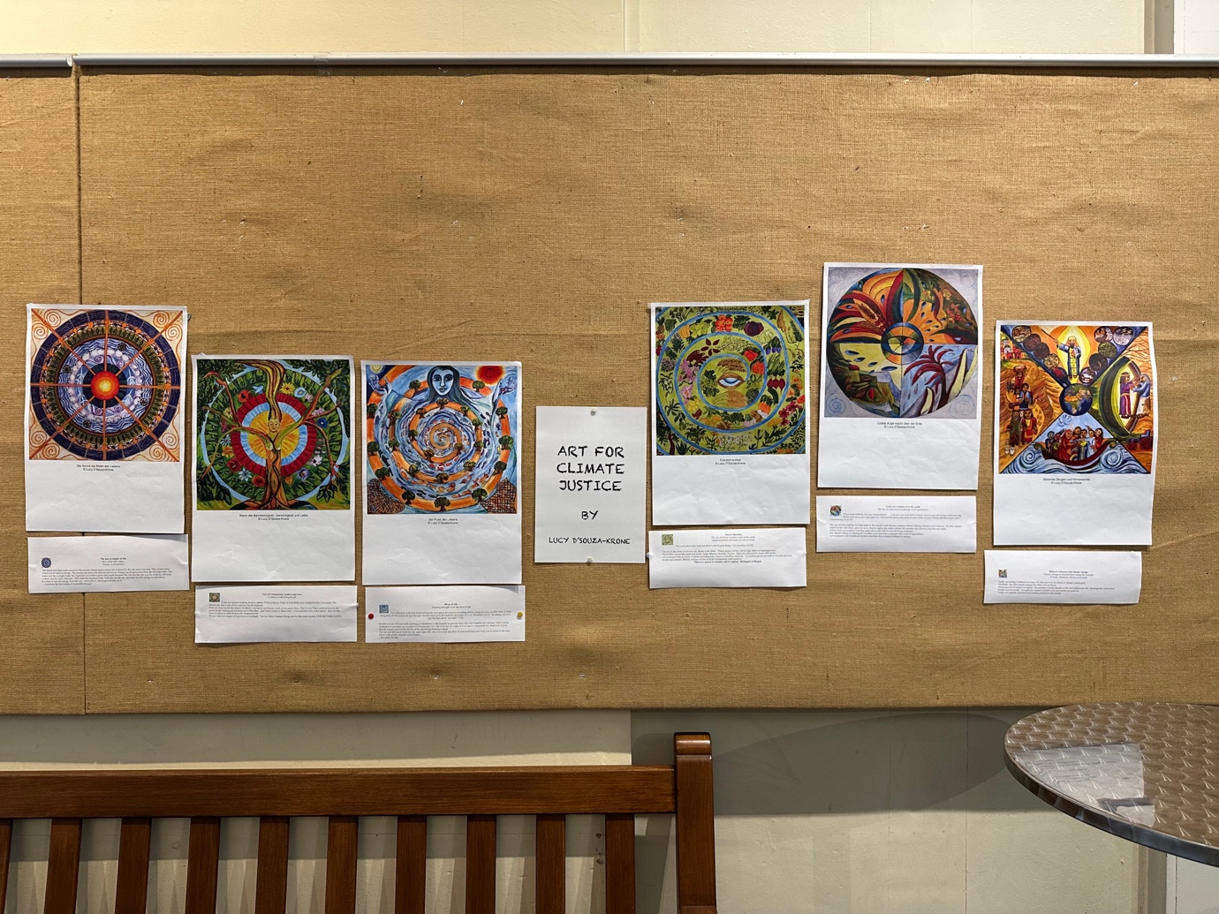
Artwork on the theme of climate change by Lucy d’Souza-Krone.

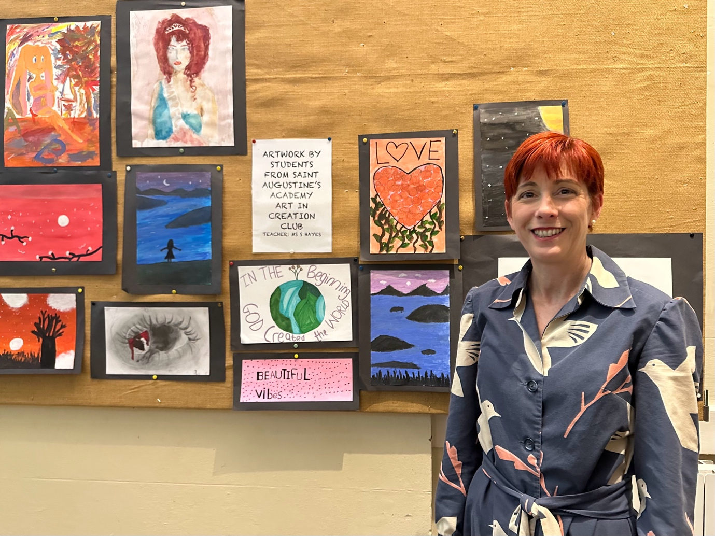
Artwork prepared especially for our event by students from St. Augustine’s Academy in Maidstone, pictured here with teacher Ms. Sarah Hayes.

