How Can You Help?  We want to continue to reach out to as many faith communities as possible to improve understanding and community integration. We are involved in several initiatives with local schools, charities and community groups and we have access to a range of resources about different faiths and beliefs.  Please tell your friends about us and ask them to get involved too!  Contact Us  Please see our website www.mifn.org.uk for more information and how to contact us.  More information about National Inter-Faith developments go to www.interfaith.org.uk. You can find out more about Kent Inter-Faith work at https://www.kent.gov.uk/leisure-and-community/your-local-community/interfaith-working  mifn booklet rev July 2022 |  |  | Maidstone  Inter-Faith Network  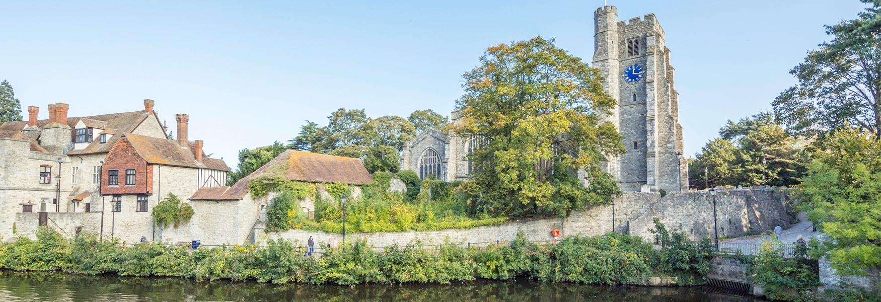  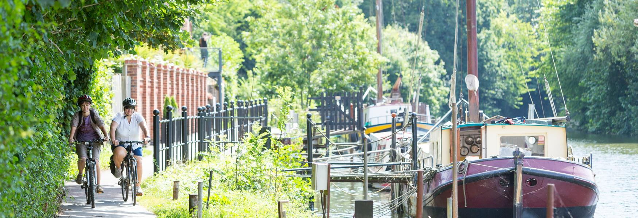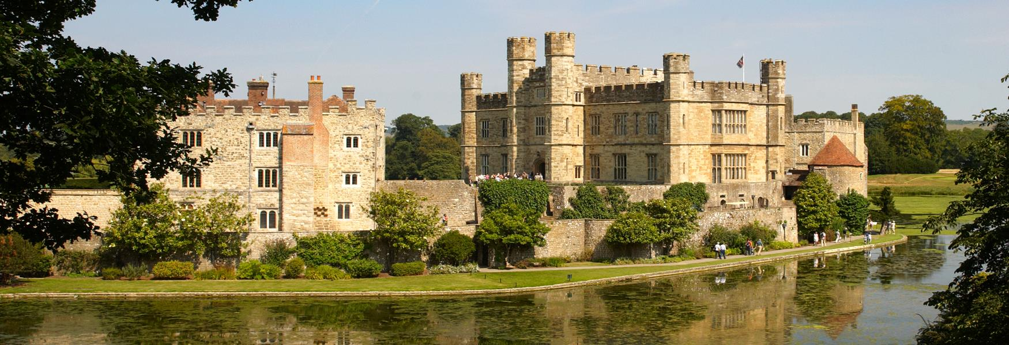  WHO WE ARE AND  WHAT WE DO
Our Vision and  Objectives  - Vision. Improved understanding, dialogue and relationships between people of different faiths and beliefs in the Maidstone area through respect of differences and recognition of similarities.  - Mission. To promote, organise and support inter-faith activities in the Maidstone area to learn about faith and belief traditions, inform others, reduce misunderstanding and improve community relationships.  - Objectives. A combination of meetings and community engagement activities which deliver the vision and mission, supporting local initiatives to improve community relationships, working with other statutory and voluntary organisations in the Maidstone area.  - Strategies. Public events will be held on a regular basis and include a range of relevant topics to deliver the Network’s mission above. Community engagement activities would be undertaken by linking with other local organisations currently involved in such projects to avoid duplication and enhance our efforts. |  |  | Who We Are  Maidstone Inter-Faith Network (MIFN) was formed in January 2018. It is made up of a number of members from different faiths and beliefs in the Maidstone area. We are a friendly group who are still growing and hope to welcome future members from other faith backgrounds in the near future.  Our Plans for 2022/23  Our plans for the year include:  - Working with children and staff in local primary and secondary schools to promote inter-faith awareness and understanding  - Working with staff, volunteers and users of local charities and community groups to improve faith knowledge and inter-faith understanding  - Assisting Kent County Council with their community cohesion and equal opportunities work  - Book launch: ‘Inter-Faith Marriage’– 23 October 2022. This is a recently published book by one of our members  - Involvement in local activities in Maidstone during National Inter-Faith Week (13-20 November 2022)  Check our website for further details.

